# COMP 3512 Assignment #1: Database-Driven Web Pages

#### Due Friday October 18, 2013 at midnightish Assignment #1 Version 1.0 (Sept 22, 2013)

## Overview

This assignment provides an opportunity for you to demonstrate your ability to generate web pages from database content using ASP.NET.

## Submitting

Put your assignment in a folder named assign1_*yourlogin* (e.g., assign1_fsmi9876). Put all resources used by your assignment into this folder. Copy this folder to the submit drive in B215. You will lose marks if you do not follow these submission instructions.

## Grading

The grade for this assignment will be broken down as follows:

Visual Design and Styling 15%

Functionality (follows requirements) 80%

## Database

In this assignment you will be provided with a Microsoft Access database containing information for an art store (i.e., artists, paintings, customers, sales, etc). The schema for the database is shown on the next page. To connect to this database, the database file (Art.mdf) will have to reside in the App_Data folder in the root of your site. You will also have to add/replace the ConnectionStrings element in your application’s Web.config file with the following:

<connectionStrings>

<add name="ConnectionString" connectionString="Provider=Microsoft.Jet.OLEDB.4.0;  
 Data Source=|DataDirectory|\art.mdb;Persist Security Info=True" providerName="System.Data.OleDb"/>

</connectionStrings>

NOTE: due to word wrapping in Microsoft Word, the above might not be clear. To clarify: the connectionString attribute is all one line that *begins* as follows:

connectionString="Provider=Microsoft.Jet.OLEDB.4.0; Data Source=|DataDirectory …

I’ve also provided you with the appropriate web.config file.

## Database Schema

While the database contains quite a few tables, this assignment will make use of only six tables: artists, works, genres, subjects, orders, and order details. Two linking tables are also used.

An art work has a single artist. An artist can have many art works. An order consists of many order details; each order has a single customer. An order detail has a single art work. An art work can have many subjects and genres.

## Examining the Database

If you have followed the instructions (i.e., database file in App_Data folder), then you will be able to examine the database within Visual Studio (since it is an Access database you can also examine it via Microsoft Access). If you double-click on the database file in the Solution Explorer, then you will see a Server Explorer window, through which you can examine the tables, or test SQL queries (via New Query). **You are NOT allowed to change data or table definitions!**

## Requirements

This assignment consists of 6 pages with the following functionality:

1. You must make use of the Bootstrap CSS Framework (http://getbootstrap.com/) to style and layout your pages. While this framework does have a little bit of a learning curve, you will find that it makes your life as a web developer significantly easier since you will be able to concentrate on programming and let Bootstrap handle the CSS. Look at the examples on the Bootstrap web site to help you understand how the make use of it. You will be using Bootstrap on the other assignments this semester so you might as well start learning it now.
2. The about page must be named about.aspx. This about page must specify that this site is an assignment for COMP 3512, your name, and the date [worth 4 marks]
3. The site **must** use a single CSS file for any additional text and color formatting. Though it is optional, you may find using Master Pages (chapter 6) helpful though not essential. [visual design worth 15 marks]
4. All pages must have six links: to Default.aspx, AboutUs.aspx, Part01_ArtistsDataList.aspx, Part02-ArtistDetails.aspx?id=19, Part03-ArtistDetails.aspx?id=394, Part04_Search.aspx pages. [worth 4 marks]
5. The home page **must** be named default.aspx. This home page must contain additional links to the pages as shown below:



I would also strongly recommend creating the following pages in the order provided below.

1. This page must be named Part01_ArtistsDataList.aspx. It must use a DataList control (see pages 587-594) to display a list of artist names (from the Artists table) that should look like that shown below. Notice the sort order. Each artist should also be a hyperlink to Part02_SingleArtist.aspx with a querystring parameter id which is equal to the id of the artist. Use a SqlDataSource for data access. The [worth 8 marks]

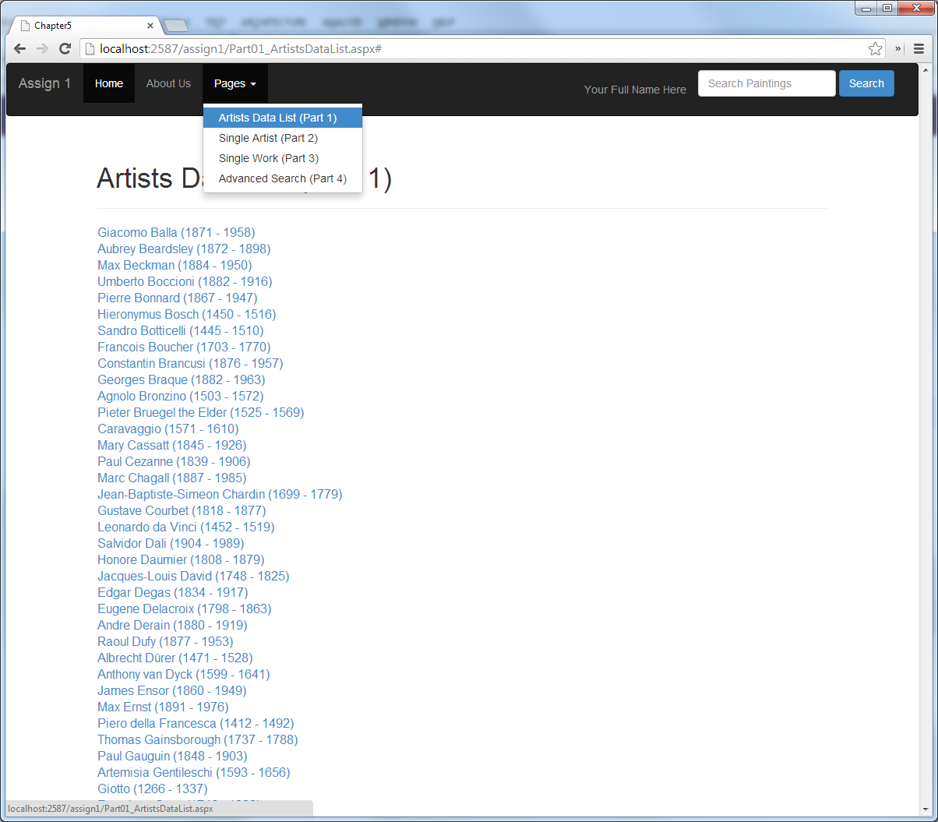

1. This page must be named Part02_SingleArtist.aspx. This page displays information from the Albums and Artists tables for a single artist (specified via the artist id passed in via a querystring parameter). You must use a Repeater or ListView control to display the artist information. This page should handle a missing or invalid querystring id parameters by redirecting to a page called Error.aspx [Hint: Response.Redirect].

The works for the artist must be displayed in an embedded Repeater control. Use the Bootstrap Thumbnail class. The work’s thumbnail, title, and the View button must be links for that work to Part03_SingleWork.aspx). Use two SqlDataSource controls for data access (one for the requested artist, the other for art works by requested artist). [worth 17 marks]

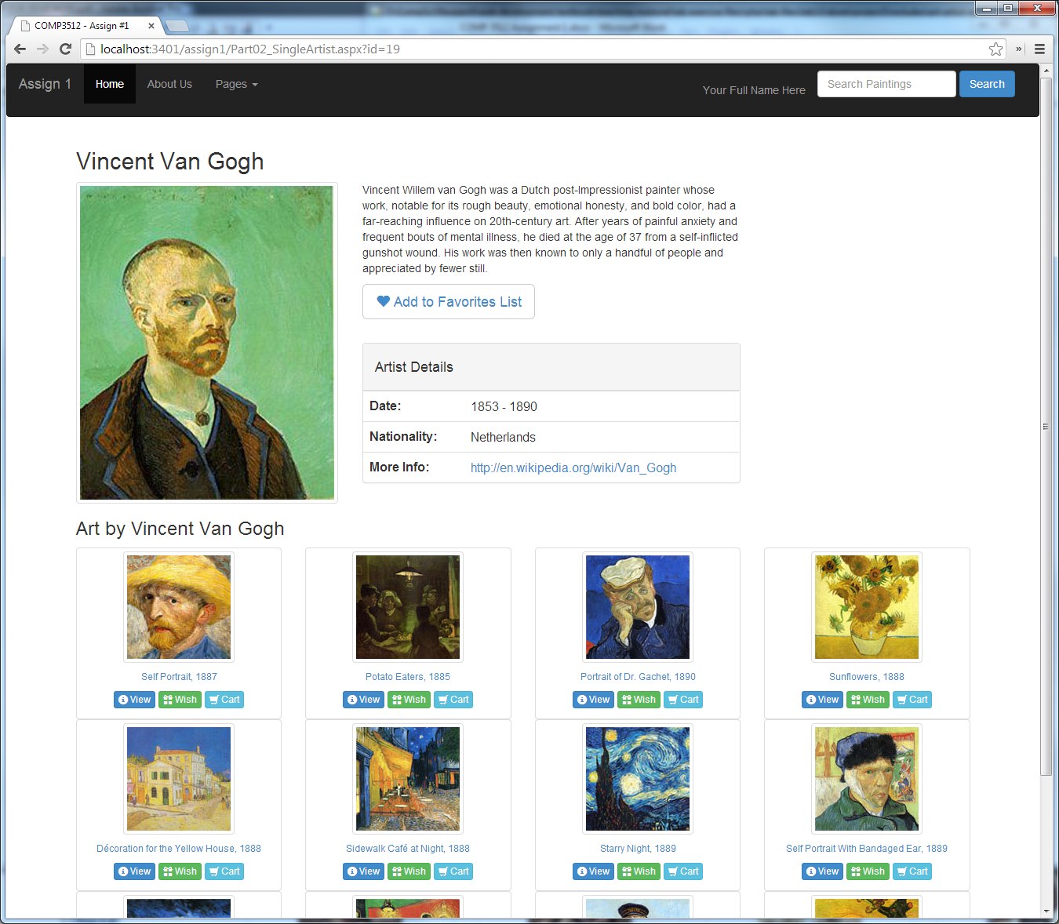

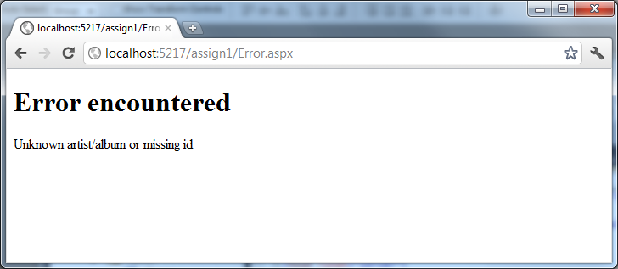

1. This page must be named Part03_SingleWork.aspx. This page displays information from the Works and Artists tables for a single work (specified via the art work id passed in via a querystring parameter). You must use a Repeater, FormView, or DetailsView control to display the painting information (hint: remember that SQL allows you to join information from multiple tables). The artist name must be a link to Part02_SingleArtist.aspx for that artist. Notice that you must also display genres and subjects for the requested art work, as well as any orders for the requested art work. Use four SqlDataSource controls for data access.  
     
   The image must be a link to the large version. Use the Bootstrap Modal dialog (in Javascript section of documentation) to display the larger version.

Like with Part02_SingleArtist.aspx this page should handle a missing or invalid querystring id parameter. [worth 22 marks]



1. This page must be named Part04_Search.aspx. It must use a Repeater or ListView control to display art work information (from the ArtWork table) that should look like that shown below. If the page is requested via a link, it should at first display only the filtering criteria. Notice that you will have to hide/show textboxes depending upon the state of the radio buttons. If the user has typed in a value in the search box in the header on any page, then it should redirect to this page using a query string, and perform a filter by Title for the query string value.   
     
   Both title and description searches should use the SQL LIKE operator with wildcards so that it matches any occurrence of the search string. When the user presses the Filter button, then display the square art work image, the title, and the description for any matching art works. The title and image must be a link to Part03_SingleWork.aspx for that art work.  
     
   If user does a filter by description, then highlight in yellow the search field in the resulting description (hint use Replace() method of string; this will be case sensitive, but don’t worry about that).   
     
   Do **not** use SqlDataSource controls for data access. Instead in this example, use programmatic data binding and ADO.NET. [worth 30 marks]



Preliminary Marking Guide COMP 3512 Assignment #1

|  |  |  |  |
| --- | --- | --- | --- |
| / 15 |  | **Visual Design and Styling**   - Text and Color Formatting + CSS usage + consistency  - Used Bootstrap appropriately   - Layout accurate Part01  - Layout accurate Part02  - Layout accurate Part03  - Layout accurate Part04  - Layout accurate Part05 | |
| / 8 |  | **Home and About Page**   - links + appropriate content  - link to home page on each page | |
| / 8 |  | **Part01_ArtistsDataListWithLinks.aspx**  - DataList, hyperlink with proper querystring id  - SqlDataSource | |
| / 17 |  | **Part02_SingleArtist.aspx**  - Data control + correct album data   - Repeater/ListView control for artist + correct data + links  - handle querystring errors  - SqlDataSource  - show art work for artist with appropriate links | |
| / 22 |  | **Part03_SingleWork.aspx**  - Data controls + correct art work, artist, order, subject, and genre data   - handle querystring errors  - Use modal dialog to show larger image  - SqlDataSource | |
| / 30 |  | **Part04_Search**  - Data controls  - Filtering  - hide/show fields  - highlight search term in description   - Proper data  - search in header works on all pages  - ADO.NET | |
| / 100 |  | Total Mark |